**Network Architecture I - Project**

Kranthi Kumar Gangineni(16261473)

Hari Manasa Ganganagunta(16258790)

Sree Naga Sayana(16256842)

**Abstract:**

Teleconferencing or Chatting, is a method of using technology to bring people and ideas together despite of the geographical barriers. The technology has been available for years but the acceptance it was quite recent. Our project is an example of a chat server. It is made up of 2 applications the client application, which runs on the user’s pc and server application, which runs on any PC on the network. To start chatting client should et connected to server where they can practice two kinds of chatting, public one (message is broadcasted to all connected users) and private one (between any 2 users only) and during the last one security. Measures were taken.

**Objectives:**

Communication over a network is one field where this tool finds wide ranging application. Chat application establishes a connection between 2 or more systems connected over an intranet or ad-hoc. This tool can be used for large scale communication and conferencing in an organization or campus of vast size, thus increasing the standard of co-operation. In addition, it converts the complex concept of sockets to a user-friendly environment. This software can have further potentials, such as file transfer and voice chatting options that can be worked upon later.

**Tools Used:**

Pycharm

**Methodology:**

We set up a socket on each end and allow a client to interact with other clients via the server. Sockets can be thought of as endpoints in a communication channel that is bidirectional and establishes communication between a server and one or more clients. The socket on the server side associates itself with some hardware port on the server side. Any client that has a socket associated with the same port can communicate with the server socket

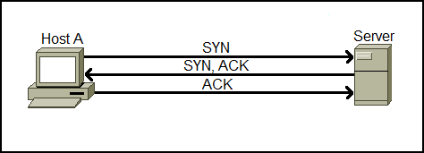

**Part I. Socket programming Warm-up**

1. **TCP server side program**

**import** sys  
**import** socket  
host = **'10.205.2.223'**port = 6363  
  
s= socket.socket(socket.AF_INET, socket.SOCK_STREAM)  
s.bind((host,port))  
s.listen(1)  
print(**"waiting for client"**)  
c, addr = s.accept()  
  
print(**"hello from client-NA1Proj "**, addr)  
  
i = **"xx"  
  
while** i != **"bye from client-NA1Proj"**:  
 i = c.recv(1024).decode()  
 print(**"received"**, repr(i))  
  
c.close()  
print(**"connection closed"**)

**TCP client side program**

**import** sys  
**import** socket  
host = **'10.205.2.223'**port = 6363  
s = socket.socket(socket.AF_INET, socket.SOCK_STREAM)  
s.connect((host, port))  
print(**"hello from server-NA1Proj"**)  
message = **"hello"  
while** message != **"bye from client-NA1Proj"**:  
 message = input(**"Type Message : "**)  
 s.send(message.encode())  
s.close()  
print(**"bye from server-NA1Proj"**)

**output:**

**Server Side:**

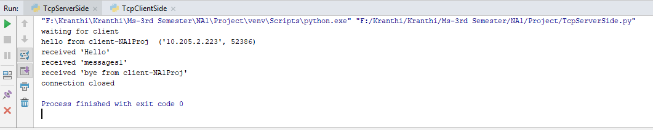

**Client Side:**

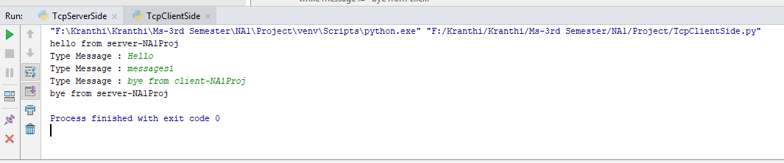

1. **TCP server side program (Text File)**

**from** socket **import** socket  
serverName = **'10.205.2.223'**serverPort = 2223  
serverSocket = socket()  
serverSocket.bind((serverName,serverPort))  
serverSocket.listen(1)  
print(**'Server is ready'**)  
connectionSocket, addr = serverSocket.accept()  
rcvd = connectionSocket.recv(1024).decode()  
print(rcvd)  
f = open(**'servermodified.txt'**,**'w'**)  
f.write(rcvd)  
f.close()  
connectionSocket.send(rcvd.encode())  
connectionSocket.close()

**TCP client side program**

**from** socket **import** socket  
serverName = **'10.205.2.223'**serverPort = 2223  
clientSocket = socket()  
clientSocket.connect((serverName,serverPort))  
f = open(**'na1.txt'**,**'r'**)  
msg = f.read()  
f.close()  
print(msg)  
clientSocket.send(msg.encode(**'utf-8'**))  
rcvd = clientSocket.recv(1024)  
print(**'From Server: \n'**, rcvd.decode())  
clientSocket.close()

**Outputs:**

Server Side:

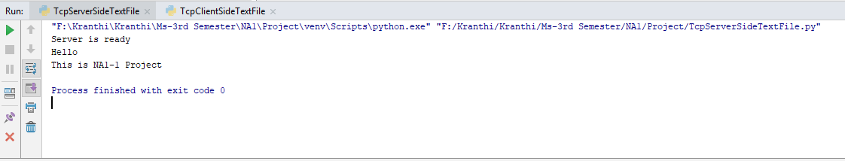

Client Side:

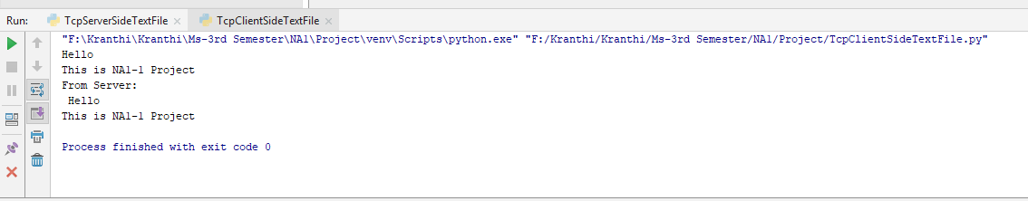

**Part II. Group Chatting Program**

1. **TCP server side program**

**import** sys  
**import** socket  
host = **'10.205.2.223'**port = 6362  
  
s= socket.socket(socket.AF_INET, socket.SOCK_STREAM)  
s.bind((host,port))  
s.listen(1)  
print(**"Waiting for clients"**)  
c, addr = s.accept()  
  
print(**"connected by "**, addr)  
  
i = **"xx"  
  
while** i != **"exit"**:  
 i = c.recv(1024).decode()  
 print(**"received"**, repr(i))  
  
c.close()  
print(**"connection closed"**)

**TCP client side program**

**import** sys  
**import** socket  
host = **'10.205.2.223'**port = 6362  
s = socket.socket(socket.AF_INET, socket.SOCK_STREAM)  
s.connect((host,port))  
print(**"Connected with server"**)  
message = **"Hello"  
  
while** message != **"exit"**:  
 message = input(**"Type Message: "**)  
 s.send(message.encode())  
s.close()  
**print("connection closed")**

**output:**

Server Side

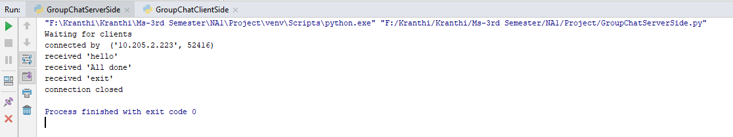

Client Side:

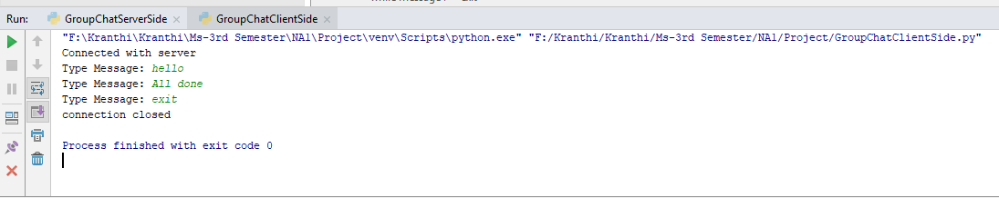

1. **TCP server side program (Number of clients)**

**import** sys  
**import** socket  
host = **'10.205.2.223'**port = 2305  
  
s = socket.socket(socket.AF_INET, socket.SOCK_STREAM)  
s.bind((host, port))  
s.listen(5)  
X = int(input(**'how many clients:'**))  
**for** j **in** range(0, X):  
 print(**"opened connection for clients"**)  
 c, addr = s.accept()  
 print(**"connected by"**, addr)  
 i = **"xx"  
 if** i != **"exit"**:  
 i = c.recv(1024).decode()  
 print(**"received"**, repr(i))  
 print(**"client"**, j+1, **'connection closed'**)

**TCP client side program**

**import** sys  
**import** socket  
host = **'10.205.2.223'**port = 2305  
  
s = socket.socket(socket.AF_INET, socket.SOCK_STREAM)  
s.connect((host, port))  
print(**"connected with server"**)  
message = **"Hello"  
  
while** message != **'exit'**:  
 message = input(**"Type message: "**)  
 s.send(message.encode())  
s.close()  
print(**"connection closed"**)

**output:**

Server Side:

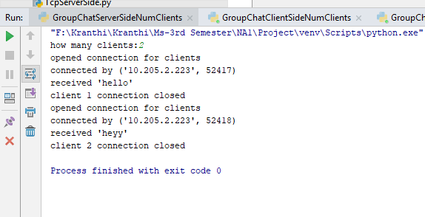

Client1 Side :

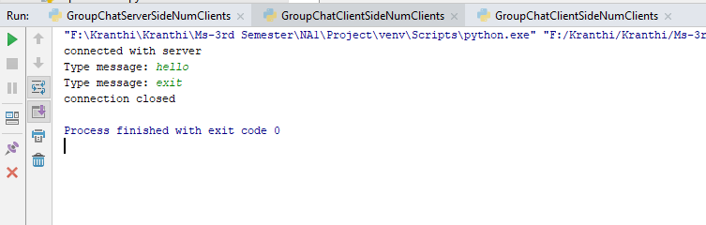

Client2 Side:

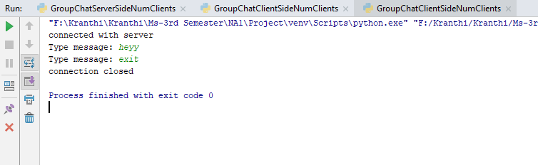

1. **TCP server side program**

**(Multiple threads receiving only on server )**

**import** sys  
**import** socket  
**import** _thread  
**from** _thread **import** start_new_thread  
host = **'10.205.2.223'**port = 2219  
s = socket.socket(socket.AF_INET, socket.SOCK_STREAM)  
s.bind((host, port))  
s.listen(5)  
**def** client_thread(c, addr):  
 print(**"connected by "**, addr)  
 i = **"xx"  
 while** i != **"exit"**:  
 i = c.recv(1024).decode()  
 print(**"received"**, addr, repr(i))  
 print(**"client connection closed"**)  
 c.close()  
**while True**:  
 print(**"opened connection for clients"**)  
 c, addr = s.accept()  
 start_new_thread(client_thread, (c, addr, ))  
print(**"connection closed with all clients"**)  
s.close()

**TCP client side program**

**import** sys  
**import** socket  
host = **'10.205.2.223'**port = 2219  
s = socket.socket(socket.AF_INET, socket.SOCK_STREAM)  
s.connect((host, port))  
message = **"Hello"**print(**' Connected '**)  
**while** message != **"exit"**:  
 message = input(**'Type Message: '**)  
 s.send(message.encode())  
s.close()  
print(**'connection closed'**)

**output:**

Server Side:

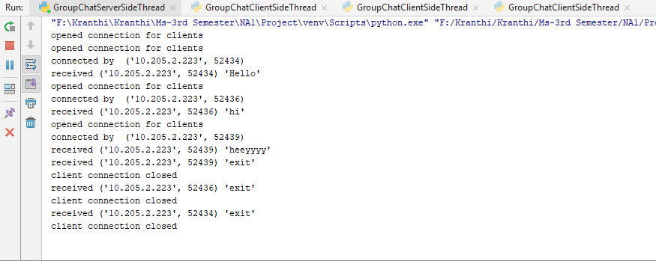

Client1 Side:

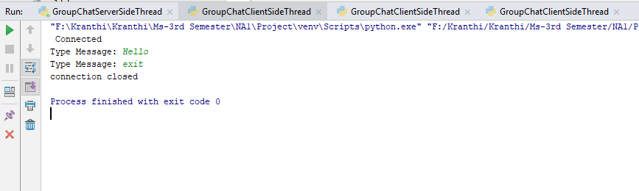

Client2 Side:

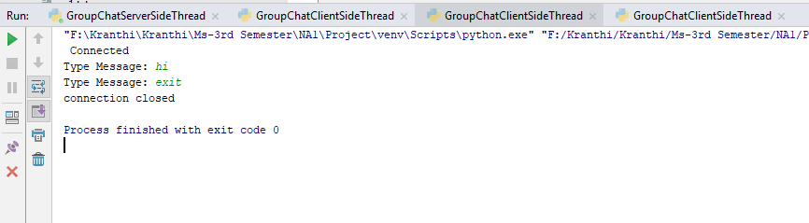

Client3 side:

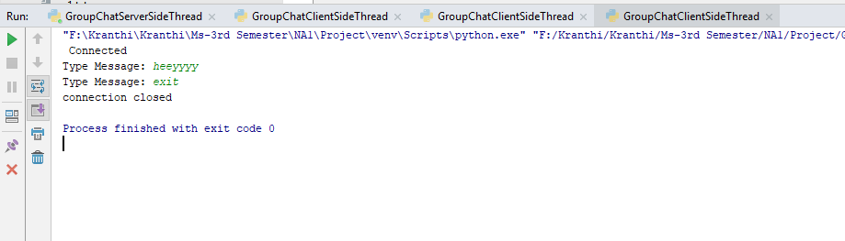

1. **TCP server side program**

**(Multiple threads receiving to both clients and server)**

**import** socket  
**import** _thread  
**from** _thread **import** start_new_thread  
host = **'10.205.2.223'**port = 2218  
s = socket.socket(socket.AF_INET, socket.SOCK_STREAM)  
s.bind((host, port))  
s.listen(5)  
client_list = [];  
**def** client_broadcast(addr,strg):  
 **for** i **in** client_list:  
 i.sendall(str(addr).encode())  
 print(**"sent to all!"**)  
**def** client_thread(c):  
 print(**"connected by "**, addr)  
 i = **"xx"  
 while** i != **"exit"**:  
 i = c.recv(1024).decode()  
 print(**"received"**, addr, repr(i))  
 start_new_thread(client_broadcast,(addr, i, ))  
 print(**"client connection closed"**, addr)  
 c.close()  
 client_list.pop(client_list.index(c));  
**while True**:  
 print(**"opened connection for clients"**)  
 c, addr = s.accept()  
 client_list.append(c);  
 start_new_thread(client_thread, (c,))  
print(**"connection closed with all clients"**)  
s.close()

**TCP client side program**

**import** sys  
**import** socket  
**import** _thread  
**from** _thread **import** start_new_thread  
host = **'10.205.2.223'**port = 2218  
s = socket.socket(socket.AF_INET, socket.SOCK_STREAM)  
s.connect((host, port))  
**def** rec_print():  
 **while True**:  
 z = s.recv(1024).decode()  
 print(**"echoed reply from:"**, z)  
message = **"Hello"**print(**"Connected "**)  
rec_thread = start_new_thread(rec_print, ())  
**while** message != **"exit"**:  
 message = input(**'Type Message: '**)  
 s.send(message.encode())  
s.close()  
print(**"connection closed"**)

**output:**

Server Side:

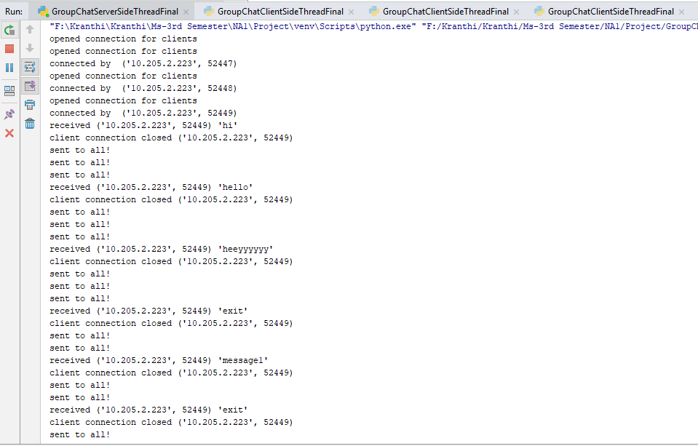

Client1 Side:

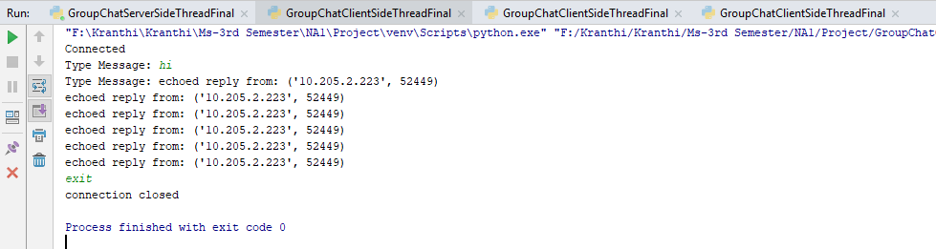

Client2 Side:

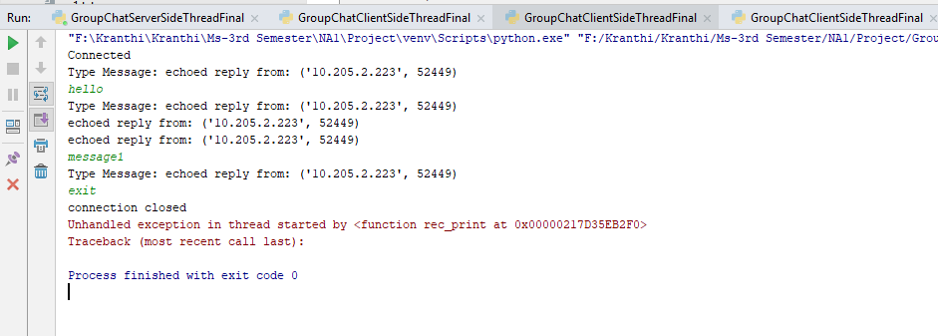

Client3 Side:

